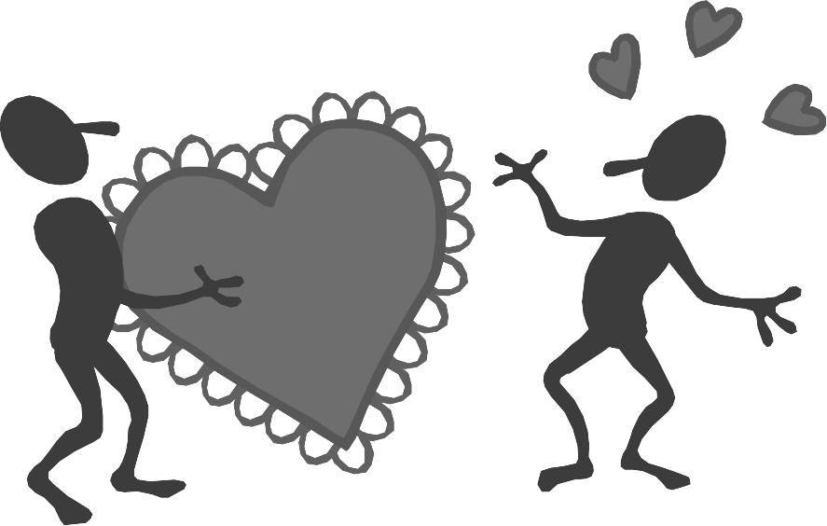

7. 1 ___________Maintain Friendships
7.1.1 _________________Determine the importance of friendship*
7.1.2 _________________Contrast types of friendships*
7.1.3 _________________Assess positive and negative aspects of peer pressure*
7.1.4 _________________Analyze problem situations involving friends*
7. 2 ___________Identify characteristics of healthy partner relationships
7.2.1 _________________Analyze factors involved in establishing healthy partner relationships*
7.2.2 _________________Identify desirable characteristics of a partner*
7.2.3 _________________Demonstrate strategies for saying no*
7.2.4 _________________Evaluate the role of friends in a healthy partner relationship*
7.2.5 _________________Analyze traits of a healthy partner relationship*
7.2.6 _________________Establish guidelines for building sound and mutually respectful relationships
7.2.7 _________________Evaluate the role of friends in a healthy partner relationship*
7.2.8 _________________Analyze effects of power imbalance and violence on each person in the partner relationship*
7.2.9 _________________Distinguish the difference between love and infatuation*
7.2.10 _________________Identify and demonstrate key elements of effective communication*
7. 3 ___________Analyze factors related to marriage
7.3.1 _________________Identify shared expectations of marriage*
7.3.2 _________________Establish guidelines for building sound and mutually respectful marriages*
7.3.3 _________________Negotiate the financial responsibilities of marriage*
7.3.4 _________________Evaluate the role of friends in a healthy marriage*
7.3.5 _________________Analyze traits of a healthy marriage*
7.3.6 _________________Analyze effects of power imbalance and violence on each person and on the marriage*
7. 4 ___________Analyze factors affecting families
7.4.1 _________________Identify the interrelationships of family members
7.4.2 _________________Analyze the impact of parents’ relationship/parent’s relationships on children
7.4.3 _________________Analyze the impact of children on the parents’/parent’s relationships
7.4.4 _________________Assess the potential effects on the family of drug, alcohol, or other substance abuse
7.4.5 _________________Assess the potential effects of extended/terminal illness on the family
7.4.6 _________________Assess the potential effects of rivalry among siblings and extended family members
7.4.7 _________________Assess the potential effects of blending families
7.4.8 _________________Assess the potential effects of family losses (e.g., divorce, death, miscarriage)
7.4.9 _________________Analyze the impact of family financial status on individuals and the family system
7.4.10 _________________Analyze the impact of parental employment status on individuals and the family system
7. 5 ___________Analyze factors related to child abuse and neglect
7.5.1 _________________Identify types and signs of abuse and neglect
7.5.2 _________________Develop procedures for protecting an abused and/or neglected child
7.5.3 _________________Identify community agencies that provide support and/or treatment for abused or neglected children
7.5.4 _________________Identify strategies for preventing child abuse or neglect
7.5.5 _________________Assess the role of drugs, alcohol, or other substance use in child abuse and/or neglect
7.5.6 _________________Identify community resources available to assist families with child abuse and/or neglect problems
7. 6 ___________Assess dynamics of domestic abuse
7.6.1 _________________Identify characteristics of domestic violence and its effects on individuals and the family system*
7.6.2 _________________Identify the victims and perpetrators of domestic violence*
7.6.3 _________________Assess own personal safety in respect to domestic violence*
7.6.4 _________________Develop a plan for personal and family safety in respect to domestic violence*
7.6.5 _________________Identify resources available to victim and perpetrators of domestic violence*
7. 7 ___________Assess dynamics of sexual abuse
7.7.1 _________________Define sexual abuse*
7.7.2 _________________Identify sexual abuse situations and their effects on individuals and the family system*
7.7.3 _________________Develop a plan to protect children from sexual abuse*
7.7.4 _________________Identify the legal aspects of disclosure and of reporting incidents of sexual abuse*
7.7.5 _________________Identify community resources available to sexual abuse victims and perpetrators*
    - _________________Research current state rules and regulations concerning convicted sexual offenders (e.g., reporting whereabouts to proper authorities,
how to find out if there are any offenders in your area, etc.*)
7. 8 ___________Manage conflict
7.8.1 _________________Identify the need for conflict management
7.8.2 _________________Identify types of conflict
7.8.3 _________________Analyze attitudes toward conflict
7.8.4 _________________Demonstrate nonviolent conflict resolution techniques
7.8.5 _________________Analyze conflict outcomes
7.8.6 _________________Apply problem-solving strategies in negotiating conflict
7.8.7 _________________Set behavior standards to use in identifying when conflict is no longer manageable
7.8.8 _________________Identify community resources available to help when conflict is no longer manageable
7.8.9 _________________Seek outside assistance when conflict is no longer manageable
7. 9 ___________Investigate family legal issues
7.9.1 _________________Analyze the legal aspects of marriage*
7.9.2 _________________Identify the need for a will and power of attorney*
7.9.3 _________________Identify the importance of family services*
7.9.4 _________________Identify resources for seeking affordable legal services*
7.9.5 _________________Establish a knowledge base for individual paternity and child support*
7.9.6 _________________Identify resources for establishing paternity and child support*
7. 10 _________Employ strategies designed to meet the basic needs of a teen-parenting family

7.10.1 _____________Enhance three-generation living arrangements*
7.10.2 _______________Identify housing needs and options*
7.10.3 _______________Identify clothing needs and options*
7.10.4 _______________Identify educational needs and options*
7.10.5 _______________Identify financial needs and income options*
7.10.6 _______________Identify informal and formal support systems available to meet needs*
7.11 _________Analyze the effect of sexually transmitted diseases (STD’s)** (cross matched with 2.4)
7.11.1 ______________Identify the symptoms, complications, and treatment for STDs
7.11.2 ______________Analyze the impact of STDs on fetal development
7.11.3 ______________Explain how STDs are transmitted
7.11.4 ______________Identify STD prevention strategies
7.11.5 ______________Identify special concerns related to AIDS/HIV-infected persons
7.11.6 ______________Identify community resources that provide assistance concerning treatment of STDs
7.12 _________Analyze sexual decisions ** (Crossed matched with 3.4)
7.12.1 _______________Set standards for making sexual decisions
7.12.2 _______________Evaluate consequences of being sexually active
7.12.3 _______________Evaluate birth-control options
7.12.4 _______________Analyze consequences of having additional pregnancies during the teen years
7.13 __________Birth Control and Pregnancy Options*
7.13.1 ________________Explain how various birth control methods work*
7.13.2 ________________Evaluate the effectiveness of various birth control methods*
7.13.3 ________________Identify advantages and disadvantages of pregnancy options*
- Marriage and raising the baby
- Single parenting
- Adoption
d. Abortion

GRADS Curriculum Unit 7
Caring Commitment and Change
Coping With Reality
Parenting Rewards and Responsibilities Chapter 26
Parenting Rewards and Responsibilities Chapter 28
Human Sexuality: Responsible Life Choices Chapter 4
Human Sexuality: Responsible Life Choices Chapter 7
Human Sexuality: Responsible Life Choices Chapter 8
Human Sexuality: Responsible Life Choices Chapter 12
Breaking Free From Partner Abuse
Reach for the Stars Unit 6
Understanding Your Changing Life Chapter 4
Understanding Your Changing Life Chapter 6
Understanding Your Changing Life Chapter 7
Understanding Your Changing Life Chapter 8
Understanding Your Changing Life Chapter 9
Understanding Your Changing Life Chapter 10
Building Your Future 2
Teen Parents and the Law Chapter 6
Teen Parents and the Law Chapter 7
Teen Parents and the Law Chapter 9
Teen Parents and the Law Chapter 10
Teen Parents and the Law Chapter 11
Teen Parents and the Law Chapter 12
Teen Parents and the Law Chapter 15
Teen Parents and the Law Chapter 16
Teen Parents and the Law Chapter 18
Teen Parents and the Law Chapter 19
Responsible Fatherhood Curriculum Session 10
Responsible Fatherhood Curriculum Session 11
Responsible Fatherhood Curriculum Session 12

